Science Forum South Africa 2021
“Igniting conversations for World Science Forum 2022”
1-3 December 2021
Proposals for Parallel Sessions organised by SFSA partners

Session Title: Biotech in agriculture: new breeding technologies

Date: Thursday 2 December 2021 | Preferred time: 09:00 11:00
Session Overview:

Global climate change is a serious threat for agriculture and in turn for food security. Indeed, events such as severe droughts or floods, as well as an increase in the intensity of pest attacks are becoming more frequent and will likely increase further. Natural tolerance, resistance or treatments for these afflictions are rare, and best practices still rely on prevention of these stresses (rather than cure). Rapid developments in agricultural biotechnology offer a solution for a more sustainable agriculture. New breeding technologies, such as genome editing with CRISPR, have recently emerged as possible solutions. CRISPR is based on an innate (yet adaptive) archaeal and bacterial immune system, that has been developed to its current commercial status by manipulating the Streptococcus pyogenes system. The technology allows for the editing of genomes with unprecedented precision, efficiency, and flexibility, and has found applications in disciplines ranging from medicine to agriculture. Crops that have been bioengineered by CRISPR and field-tested include maize, wheat, rice, sorghum, soybeans, cucumber, potatoes, tomatoes and oranges. Most of the traits can be summarized as agronomic traits, followed by food and feed quality, and biotic stress tolerance.
In this session we are going to showcase some exciting and interesting examples of recent research in agriculture (as well as other disciplines) from Italy and South Africa, in order to give an idea of the potential applications of new breeding technologies. An overview of what is currently occurring around the world in terms of products and regulations will be given. This will be viewed in the African and in particular the South African context.
The aim of the session will be to explain what is genome editing technology, and what are the potentials for this new technology. How it can benefit agriculture and what are the possible challenges in the future?

Programme: (Description of the running order of the session – 90 minutes)
Short intro by the moderator 5 min max
Presentations by the panelist (5-8 min each)
- Dr Lorenza Dalla Costa (Foundation Edmund Mach (FEM), Italy) dallacosta.lorenza@gmail.com

- Prof Dave Berger (Department of Plant and Soil Sciences and the Forestry and Agricultural Biotechnology Institute (FABI), University of Pretoria, South Africa) dave.berger@fabi.up.ac.za

- Dr Priyen Pillay (CSIR, South Africa) ppillay3@csir.co.za

- Mrs Chantel Arendse (CropLife, South Africa) chantel@croplife.co.za

- Mr Josphat N. Muchiri (Kenya National Biosafety Authority) jmuchiri@biosafetykenya.go.ke

- Dr Julian B Jaftha (GMO Executive Council Chairperson, South Africa) (To be confirmed) julianj@dalrrd.gov.za

- Dr Hennie Groenewald (Biosafety South Africa) hennie@biosafety.org.za

Discussion

Moderator: (Name and maximum 100 words biographical summaries – URL link if relevant)
Dr Manuela Campa
mcampa@sun.ac.za
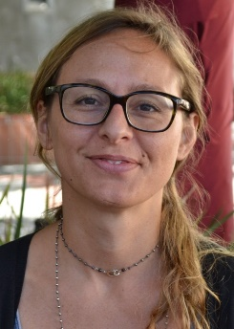
Dr Manuela Campa

Manuela Campa is a researcher at Stellenbosch University. Dr Campa obtained her PhD in Biotechnology at the University of Insubria, in Italy in 2007. Following post-doctoral fellow positions at a few Italian universities and research institutes, Manuela joined the research group of Prof Johan Burger at the Genetics department of Stellenbosch University in 2014. Her research covers most aspects of plant biotechnology and she recently started to expand her experience in genome editing technology to crops like grapevine, wheat and potatoes in order to improve resistance to biotic and abiotic stresses.

Speakers

Dr. Lorenza Dalla Costa,
PhD, Researcher at Foundation Edmund Mach (FEM), Italy
Dr. Lorenza Dalla Costa deals with genetic improvement of grapevine using gene transfer techniques in order to modify traits involved in resistance/tolerance to pathogens or related to the fruit quality. In recent years, she has applied new plant breeding technologies (NPBT) such as Zinc Finger nucleases (ZFN), cisgenesis, CRISPR/Cas9. She also developed innovative analytical methods for the molecular characterization of genetically modified plants. She is the author of several publications in the plant biotechnology sector.
orcid 0000-0001-5915-5582
Researchgate https://www.researchgate.net/profile/Lorenza-Dalla-Costa
Linkedin linkedin.com/in/lorenza-dalla-costa-35aa5467
Prof. Dave Berger
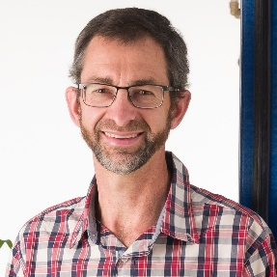
Dave Berger is a professor in the Department of Plant and Soil Sciences and the Forestry and Agricultural Biotechnology Institute (FABI) at the University of Pretoria. As a plant biotechnologist, he conducts collaborative research on crop diseases of economic importance in Africa and globally. His main research aim is to develop sustainable management strategies for long-term food security. He holds a B2 rating (“internationally acclaimed researcher”) from the National Research Foundation of South Africa, and in 2013 was a USDA Norman E. Borlaug International Agricultural Science and Technology Fellow at the University of Arkansas, USA. He was recipient of the 2016 Special Award for Crop Science and Food Security from the National Science and Technology Forum/South 32. Research website: http://tinyurl.com/FABI-MPPI

Dr Priyen Pillay
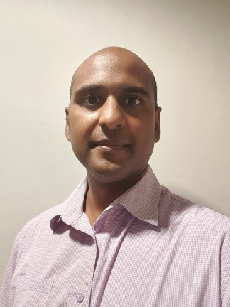
I am currently a Senior Researcher at the CSIR Chemicals Cluster, Technology Demonstration group under Dr Tsepo Tsekoa. We are involved in metagenomics as well as plant biopharming. Our team has developed technologies for purifying and formulating genome editing enzymes, Cas9 and a novel T7 endonuclease, at Trl 6. We also conduct research on genome editing in bacteria, Rhodococcus and Lactobacillus and plants, Nicotiana benthamiana. We are currently employing the Cripsr/Cas9 technology for metabolic pathway engineering in Rhodococcus and Lactobacillus, and recombinant protein production enhancement in plants. I have a strong network and I wish to build upon it.

Chantel Arendse
Chantel Arendse is the Plant Biotechnology Lead at CropLife South Africa, where she represents the interests of industry members by supporting the successful commercialisation of plant biotech products as well as trade of biotech commodities into and out of South Africa. Prior to this appointment, she held various positions at the Department of Agriculture in South Africa and more recently, the United States Department of Agriculture - Animal and Plant Health Inspection Services (USDA-APHIS) where she was responsible for regulatory policy issues such as Biosecurity, Biotechnology and Plant Improvement.

Josphat N. Muchiri
Mr. Josphat Muchiri is the Deputy Director, Technical Services and Head of Biosafety Risk Evaluation Department at the Kenya National Biosafety Authority. He is also Kenya’s National Focal Point for the Biosafety Clearing House (BCH) and Contact Person for Emergency Measures for the Cartagena Protocol on Biosafety.
Mr. Muchiri received his Bachelor Degree in Agriculture from University of Nairobi (2000), Master’s Degree in Horticulture, University of Nairobi (2005) and Master’s Degree, Biosafety in Plant Biotechnology from Marche Polytechnic University, Italy (2013).
Prior to his current position, Mr. Muchiri has held entry and mid-level positions at the National Biosafety Authority since 2011. Previously, he worked with the Kenya Plant Health Inspectorate Service (KEPHIS) as a seed specialist and plant examiner. Mr. Muchiri was a member of the Ad Hoc Technical Expert Group (AHTEG) on Risk Assessment and Risk Management of LMOs between year 2014 and 2016. He has facilitated in various fora nationally and internationally as an expert on biosafety regulatory frameworks in Kenya and other diverse topics related to biotechnology, biosafety and emerging technologies.

Dr Julian B. Jaftha
GMO Executive Council Chairperson
Chief Director: Plant Production & Health

Dr Hennie Groenewald
Hennie Groenewald is the executive manager of Biosafety South Africa, a national biosafety service platform, within the Technology Innovation Agency and under the auspices of the national Department of Science and Innovation.
It is the principal instrument within the national biotech innovation system which enables compliant, sustainable and effective research & development, innovation and commercialisation in the biotech sector. He has 28 years of experience in biotechnology research and development, teaching, biosafety risk analysis and governance, science communication, business development and innovation management in the public, private and academic sectors. Prior to joining Biosafety South Africa, he worked at Stellenbosch University, the South African Sugarcane Research Institute and North-West University. Hennie was a founding member of two successful South African biotech start-ups and has served on numerous international and national bodies tasked with responsible research and innovation, biosafety and risk governance and capacity building, medicines control, science
communication and sustainable biotech and agricultural innovation.

Session organiser(s): (Names of institutions and contact details of contact person – URL links if relevant)
Dr Pierguido Sarti, Italian Embassy
Dr Manuela Campa, Stellenbosch University
Dr Vittorio Venturi, International Centre for Genetic Engineering and Biotechnology

Please return to: Thapelo.Kepadisa@dst.gov.za

